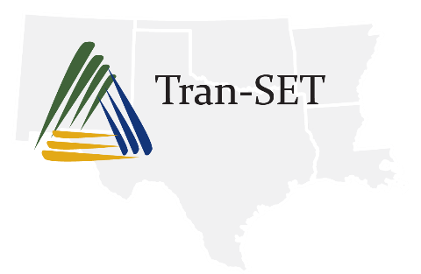
Transportation Consortium of South Central States
Solving Emerging Transportation Resiliency, Sustainability, and Economic Challenges through the Use of Innovative Materials and Construction Methods: From Research to Implementation

Progress Report

0. Project Information
Element | Information
Project Title
Project ID
Principal Investigator(s)
Participating University/Institutions

1. Accomplishments

1.1. Accomplishments [This Reporting Period]
Please succinctly describe the progress and accomplishments that have occurred this reporting period. Please state technical progress (on the research), any training and/or professional development activities, educational activities, or other outreach-related accomplishments. Please only report activities/accomplishments from this reporting period.

1.2. Anticipated Accomplishments [Next Reporting Period]
Please succinctly describe the progress and accomplishments anticipated next reporting period.

2. Participants & Collaborating Organizations
For this section, if there is nothing significant to report, state “Nothing to Report.” and delete the table templates. Generally, it is unlikely that partners or collaborators will change from one reporting period to the next. However, if there are changes (i.e., additional partners or collaborators), please list and highlight in yellow.

2.1. Partners [General, Update if Necessary]
Partners may provide financial or in-kind support, supply facilities or equipment, collaborate in the research, exchange personnel, or otherwise contribute. Please list the organization name, type (nonprofit, industrial firm, government, or academic institution), location (city and state), and brief description of contribution. Please delete and add rows as necessary.
Organization Name | Type | Location | Brief Description of Contribution

2.2. Collaborators [General, Update if Necessary]
Some significant collaborators or contacts may not be covered in the above section. These may be collaborations with others within the lead or partnering universities, outside Tran-SET, or even international organizations. Please list the requested information in the same manner as the above section. Please delete and add rows as necessary.
Organization Name | Type | Location | Brief Description of Contribution

3. Outcomes
Please describe how findings, results, techniques developed or improved, or other products from the project are anticipated to produce outcomes. Examples of outcomes include: (a) increased understanding and awareness of transportation issues, (b) passage of new policies, regulation, rulemaking, or legislation, (c) increases in the body of knowledge, (d) improved processes, technologies, techniques, and skills in addressing transportation issues, (e) enlargement of the pool of trained transportation professionals, and (f) adoption of new technologies, techniques, or practices.
Generally, outcomes of the project will not change from one reporting period to the next. However, if there are changes, please describe and highlight in yellow.

4. Impact
For this section, if there is nothing significant to report, state “Nothing to Report.” Generally, anticipated impacts of the project will not change from one reporting period to the next. However, if there are changes, please describe and highlight in yellow. It is expected that the research will impact at least one of the following areas.

4.1. Impact on Effectiveness of the Transportation System [General, Update if Necessary]
Please describe how findings, results, techniques developed or improved, or other products from the project are likely to make an impact on the operations and effectiveness of the transportation system.

4.2. Impact on Adoption of New Practices and Commercialization [General, Update if Necessary]
Please describe ways in which the project is likely to make an impact on commercial technology or public use, including: (a) transfer of results to entities in government or industry, (b) instances where the research has led to commercialization of a technology or process, or (c) adoption of new practices.

4.3. Impact on the Body of Scientific Knowledge [General, Update if Necessary]
Please describe ways in which the project is likely to make an impact of the base knowledge, theory, research, and/or pedagogical methods in the principal disciplinary field(s).

4.4. Impact on Transportation Workforce Development [General, Update if Necessary]
Please describe how the project is likely to make an impact on transportation workforce development. This may involve developing new educational materials, hosting trainings, providing learning opportunities to underrepresented groups, etc.

4. Changes/Problems
For this section, if there is nothing significant to report, state “Nothing to Report.”

4.1. Changes in Approach [This Reporting Period]
Please describe any changes in approach and reasons for these changes. Please only report changes occurring this reporting period.

4.2. Actual or Anticipated Problems/Delays [This Reporting Period]
Please describe problems or delays encountered and actions or plans to resolve them. Please only report changes occurring this reporting period.

